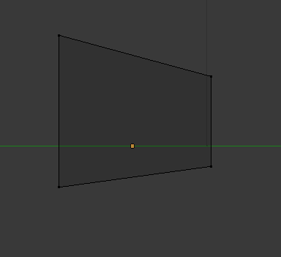**Blender model tutorial**

Start with a cube and select just the left vertices and scale in the **Z** axis to enlarge it. Then select just the right side of vertices and scale in the **Z** axis again to shrink it.

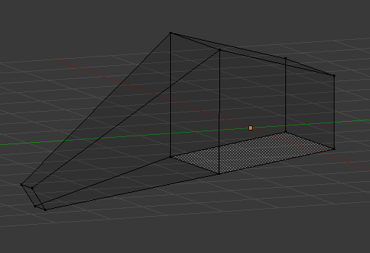Extrude the left face about 3 units in the **Y** axis and translate the vertices downwards by **2** units

Now scale the face down and rotate to face downwards, you should have this. This will be the nose of our spaceship

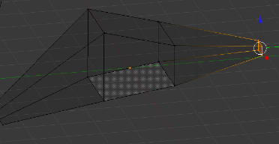

Now select the right face of the object and extrude by **2.5** units then scale down the face. This will be our tail end of the spaceship

Now switch to top view with **NUM7** and scale in the middle portion to make the body thinner

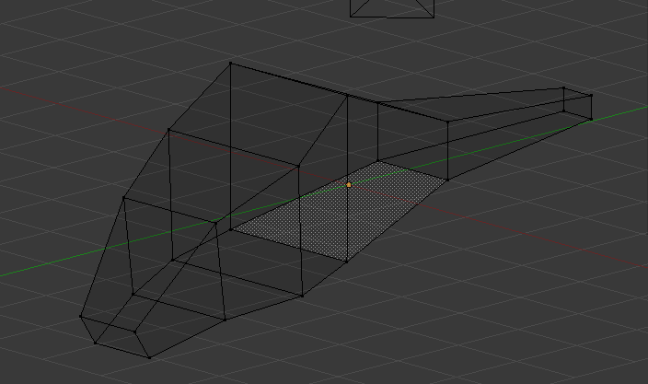Use the loop and cut slide tool to create edges about a third of the distance from the middle block. You can use the shortcut **CTRL + R**

Then switch to top view and widen. Do this once more, nearer to the nose.

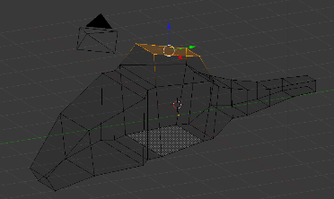Use the loop and cut tool on the tail end to make it taper towards the end and give it a more organic look. You can add more loops and make the shape more details like I have on the next. What we really need is a basic shape that will be the base of the spaceship model. Next extrude the top face of the mid-section, this is where the wings will be attached.

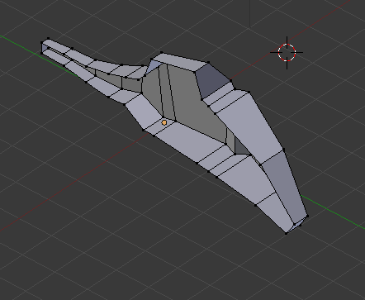

Now add a loop cut down the middle of the body, lengthwise. select the left side of the object. Then, delete the faces, you should have this.

Now, using **SHIFT + S**, move cursor to selected and add a mirror modifier. In the settings for the modifier make sure clipping is enabled and that the mirror is on the x axis. Now our model back to being whole.

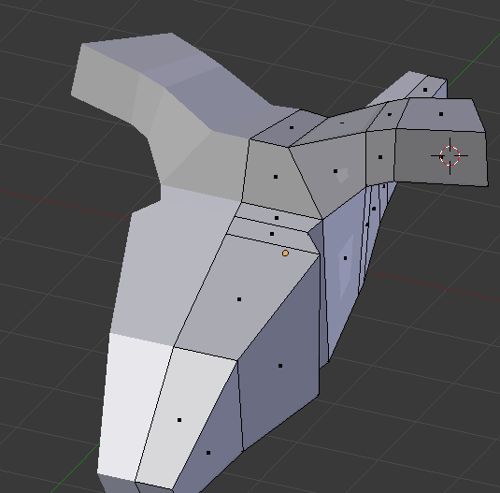

Now start extruding from the middle top cube to bring out the wings

notice you only need to change the right side and the left will mirror the right.

Extrude and change the shape of the wings to how you want it. Try to get a curve in there.

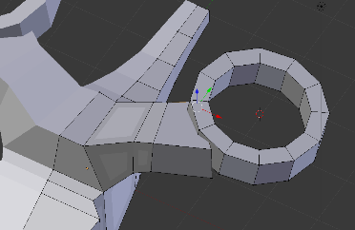Next add a circle to model the fans. Use **SHIFT + A** then **mesh -> circle**. Set the vertices to 12

Scale the circle to the right size to match the wings and then extrude inwards Then extrude down to give It thickness

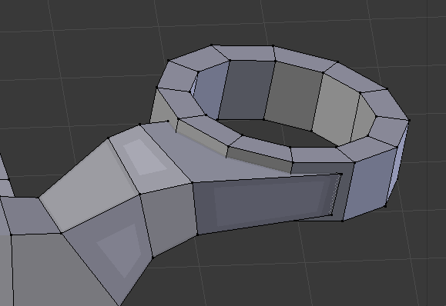

Now to match the wings to the circle, use the translate tool G to move the vertices of the wing to join onto the circle. It doesn’t have to be too accurate now, we will join it properly later on.

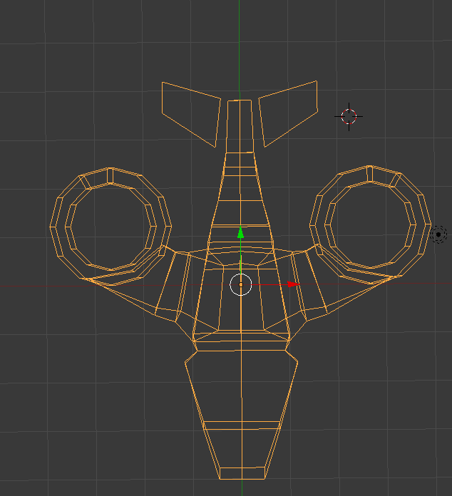

Now to add the tail fins for the plane.

Go to the top view **NUM7** and add a cube near the tail end

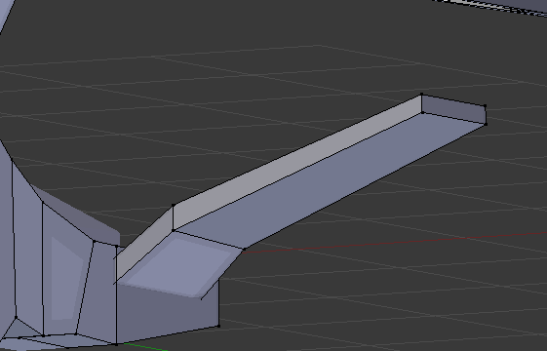

Translate the vertices to resemble a tail fin shape

Scale the cube so that it is flatter and then extrude to connect to the body

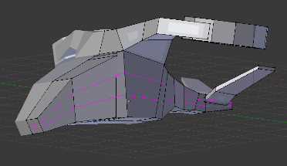

Next up we’re going to add two loop cuts along the side

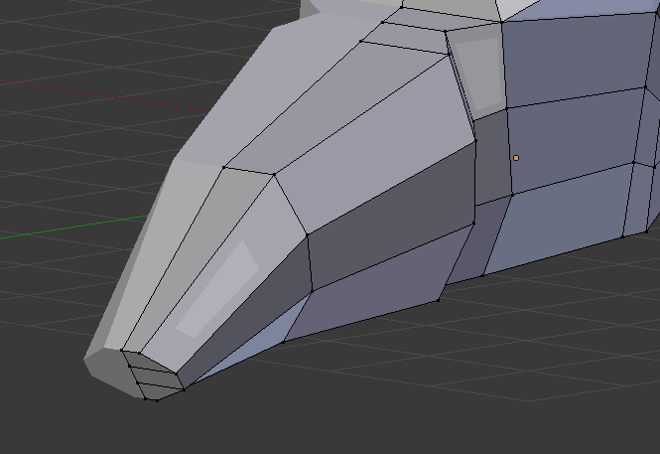

Now select the new vertices created by the loop cut and use **G X** to bring them in closer and give the nose of the ship a more rounded look.

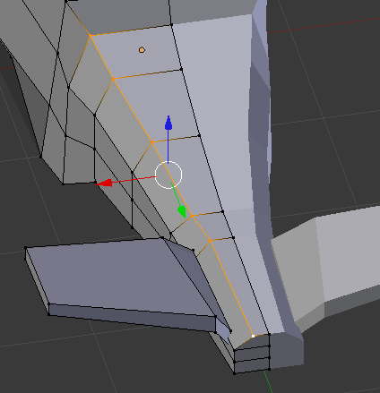

Do the same with the bottom vertices and the same with the tail end

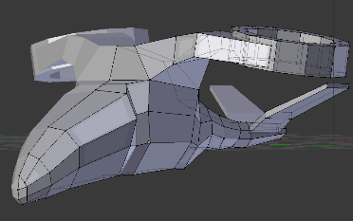

Now switch to front view **NUM1** and rotate to side with **CTRL + ALT + SCROLL**

we are going to make the wing area join the nose in a smoother fashion

Select this area of the model

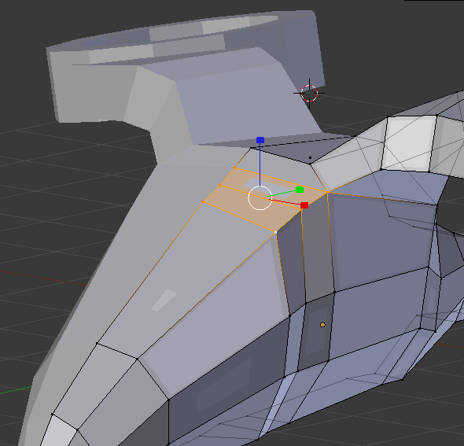

And raise it to reduce the hump on the wings

Also use **G Z** to translate the hump of the wings down a little

next we are going to split this section up with the V key

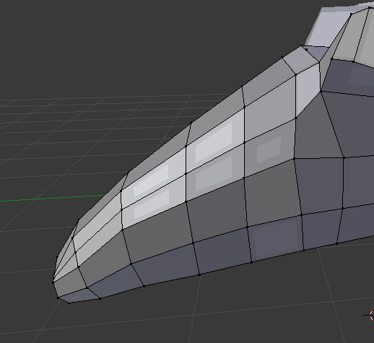Here we are going to improve the mesh flow by evening out the edges and vertices

Select the edges going down the vehicle, duplicate them and use edge slide to move it across

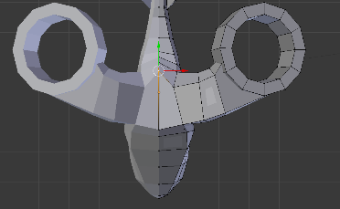Next we are going to adjust the top of the vehicle a bit. By bringing the middle vertex down and back

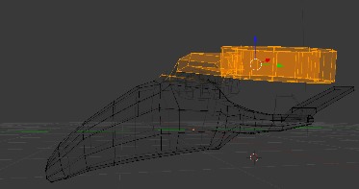

Next we are going to lower the wing slightly

Select the just the wing with **B** and hit **O** and lower the wing with **B** then **Z**

Now time to add some colour

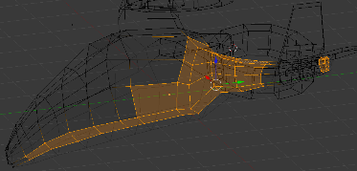Select the main body and go to the material section and give it a colour, for mine, I’ve given It a light blue colour. And a different colour for the windscreen

Next select the underside of the vehicle and go to materials and give this section a black colour or dark grey

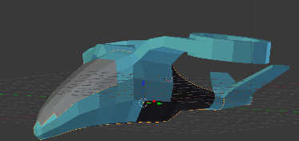

We are going to add detail to the windshield

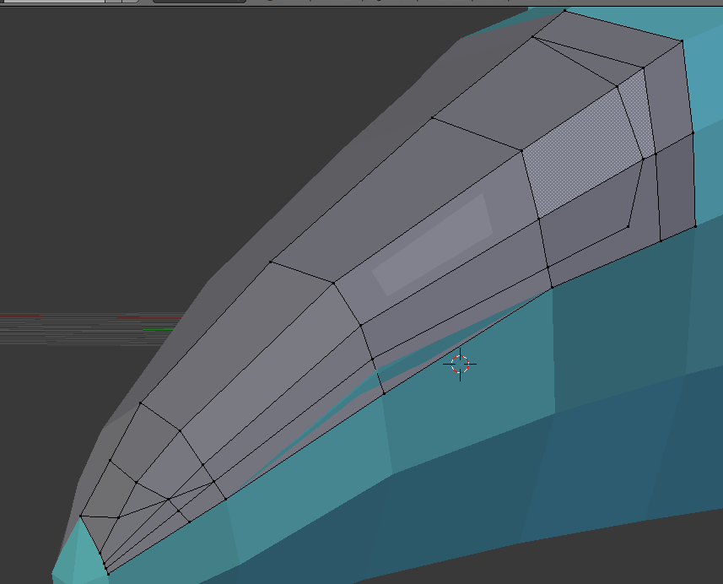create an oval shape in the windshield by creating vertexes using subdivide then connecting the vertices with the **F** key

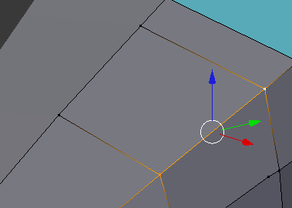

Select two vertices then open special menu and click subdivide

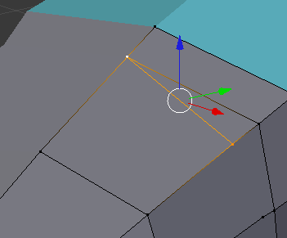

Now click the new vertex and the vertex you wish to connect and click **F** continue this until you have an oval shape

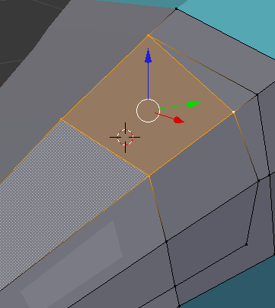

We have a problem

Our oval area doesn’t have its own faces so we will create them

select the 4 points and click **F**, it will create a face

Switch to face select and you should see and extra dot indicating an additional face

Do this for the rest of the faces around the oval edge

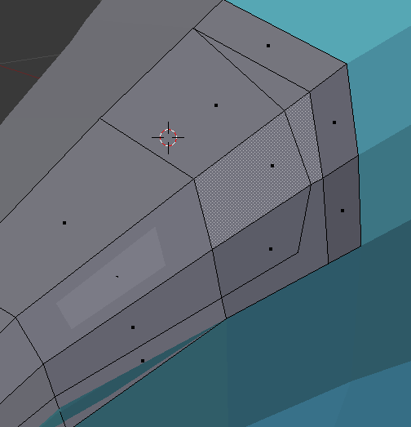

Select the oval area and extrude in **X** axis by **-0.05** then select the whole windshield and remove doubles

Now extrude in **Z** axis by **-0.05**

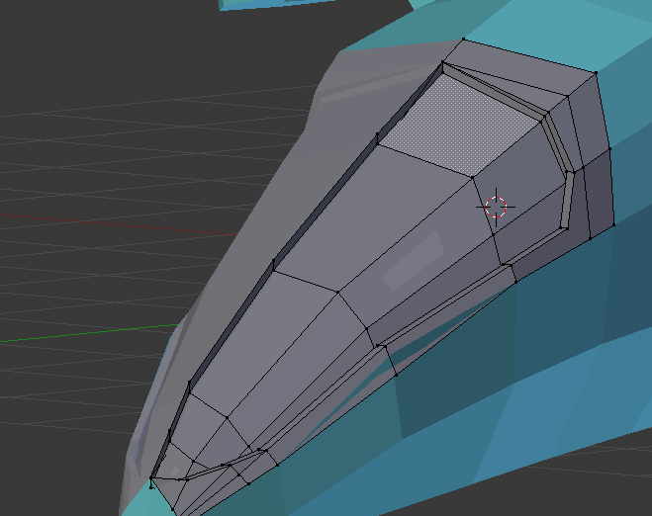Now delete the extra edges in the middle

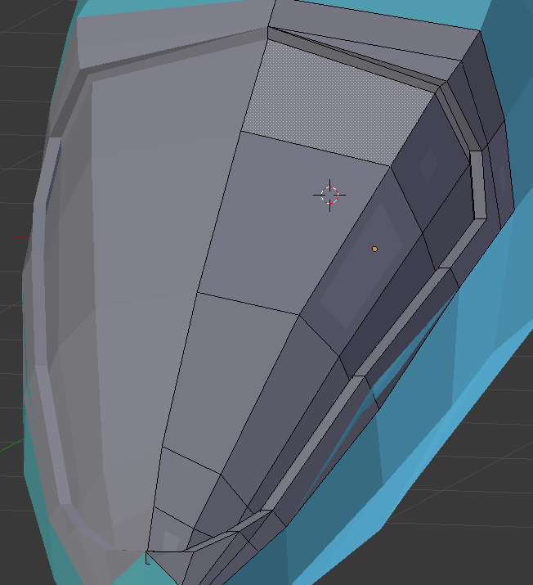You should have this

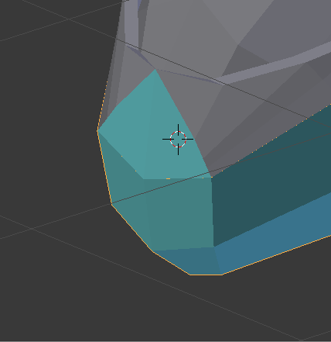Notice this section should be part of the windshield, change the colour to match the windshield

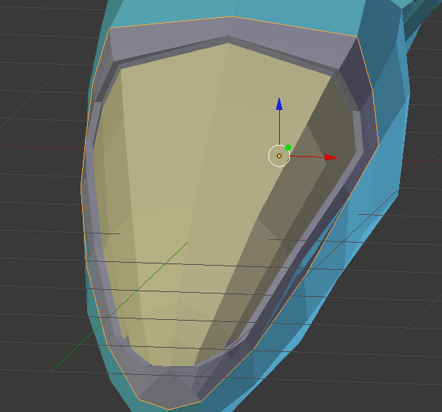Next change the colour of the window of the windshield to a yellowish colour by adding a new material in the materials panel and assigning it to the windshield area.

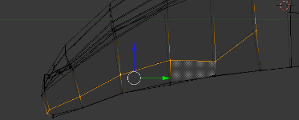We are now going add some detailing to the body. Select these vertices

Aim for this kind of shape

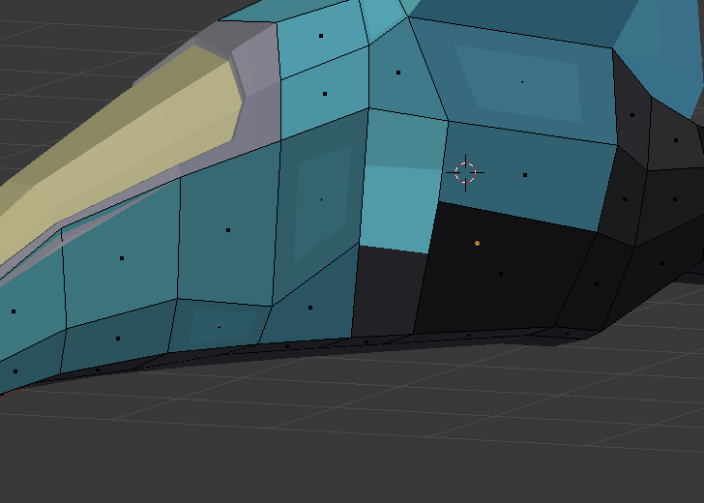Delete these two faces for the time being

Create a loop cut near the line you bent earlier

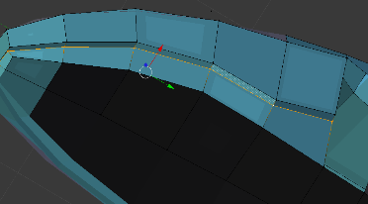And use **G X** to move it inwards a little then use **S Y** to scale it inwards by **1**

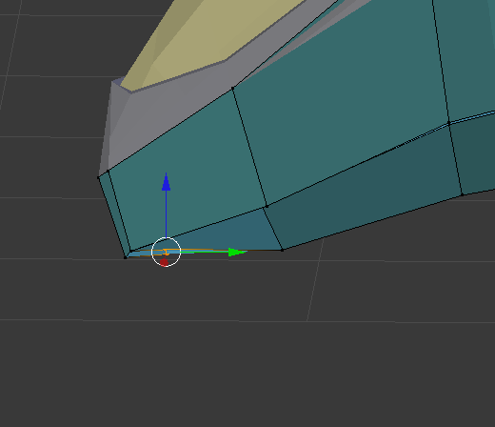Now bring in the nose tip a little

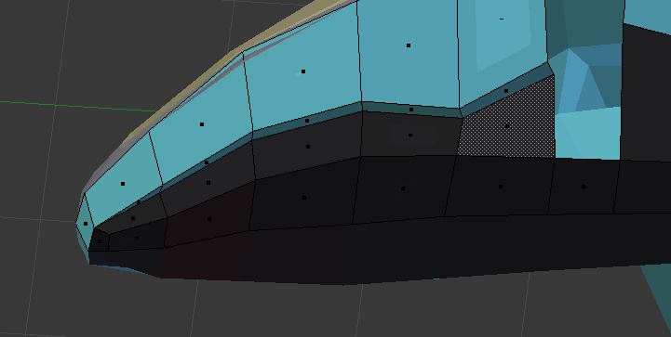Change the color of the underside to dark grey

Add two loop cuts 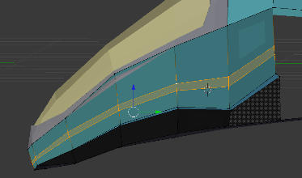

Select the bottom loop cut you created and translate it in the **X** axis by a small amount

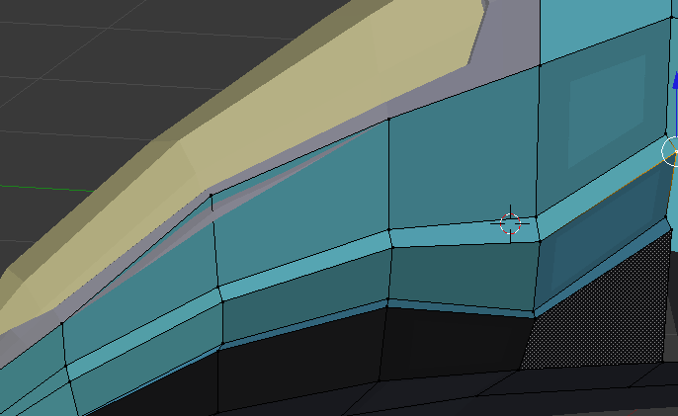

Do the same technique above again

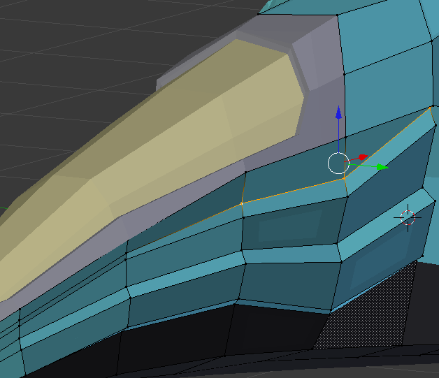

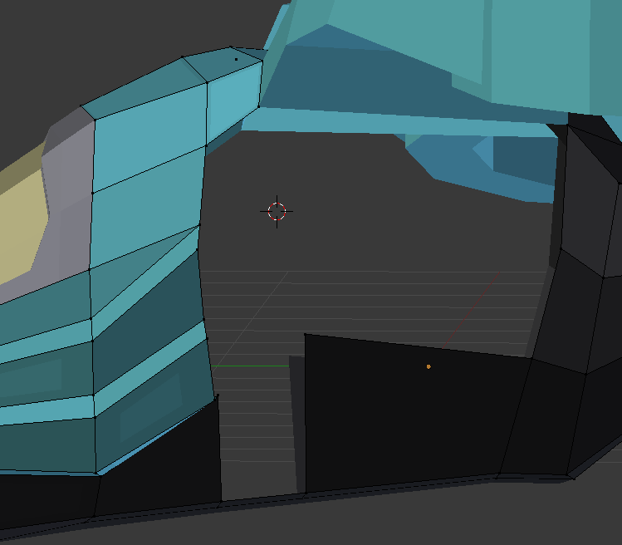Delete these faces as we are going to extrude the body detailing in that area

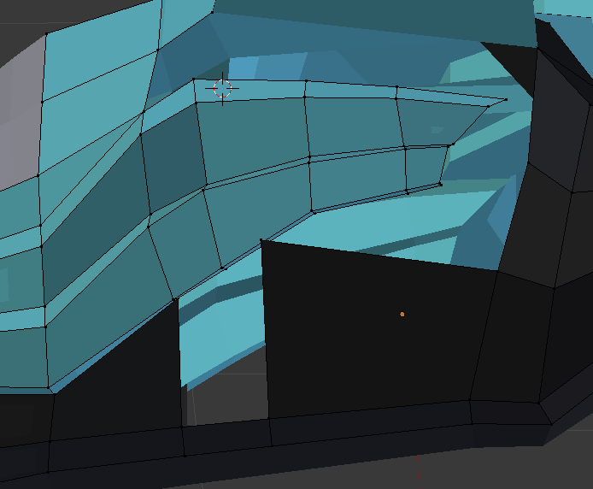

Select the body detailing you have just done and extrude it along the body of the plane. Try to match the shape as shown in the image.

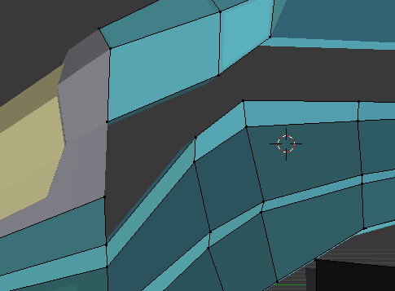

Delete these faces

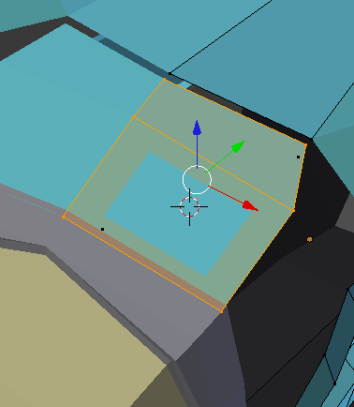

Go to top view select top two panels and disconnect them using **Y**

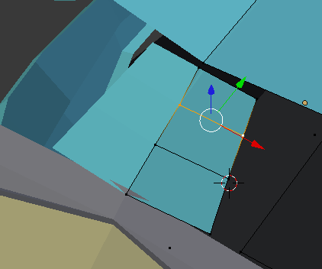Make the panel smaller by using **G** on the **X** axis then add a loop cut going across and place the edges an even distance apart

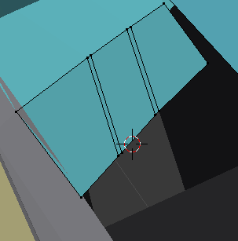Add two more loops and select them both, then translate them on **X** axis a small amount

Next reconnect the panel to the spaceship

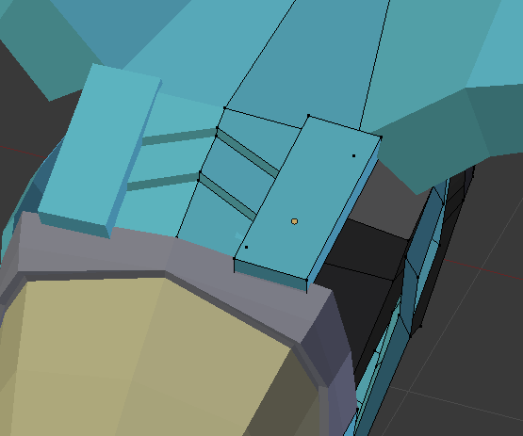Now create a new cube

Scale it down using **S** and **Z** and align it to fit in the empty space

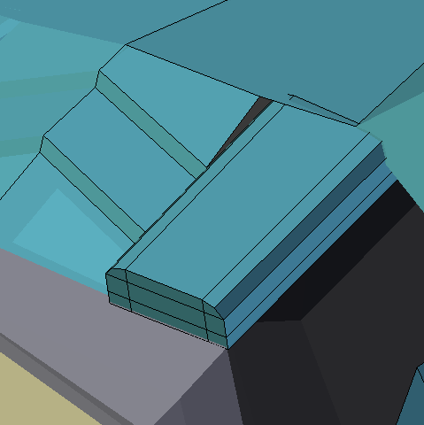Add loop cuts as shown in the image. Then select the edges of the cube and translate them inwards to give the cube a rounded edge effect.

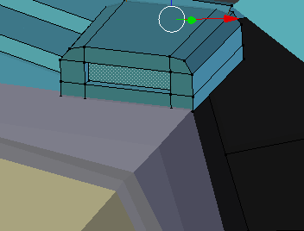

Select the front inner face and extrude and translate it inwards into the cube.

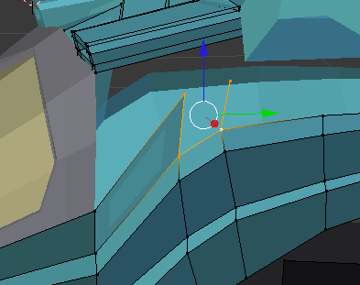

Start filing in the area in the main body by extruding the body panels.

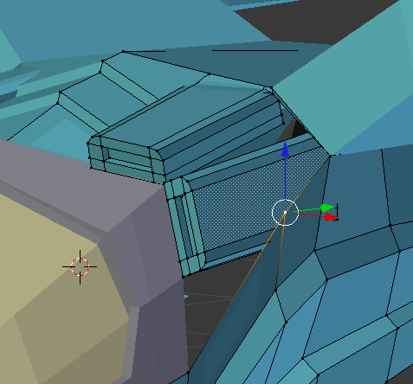Duplicate the cube we made earlier and place it in the empty space we have

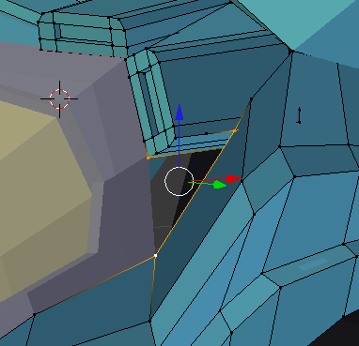

Subdivide this top line to create a vertex and use it to create a face to cover up the empty space

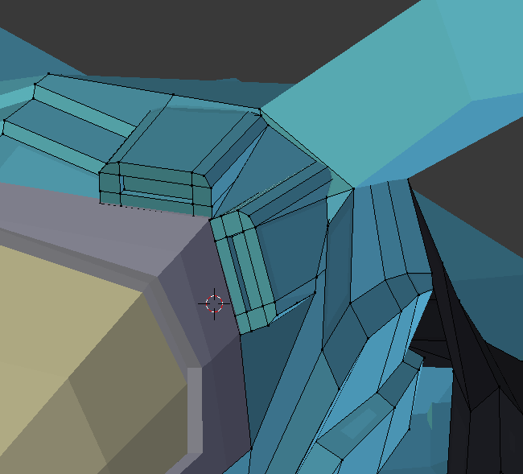

Do the same for the other empty areas near the wings.

Now add the wheel we created earlier.

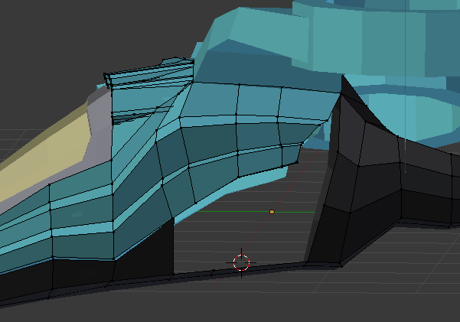

Now we are going to create a Wheel to put in the empty space.

**Wheel Tutorial**

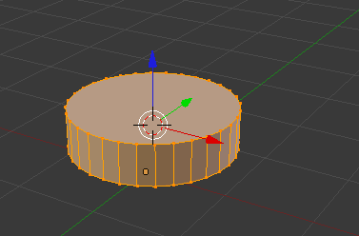Open a new blender file, remove the cube.

Create a cylinder and scale it down **0.25** in **Z** axis

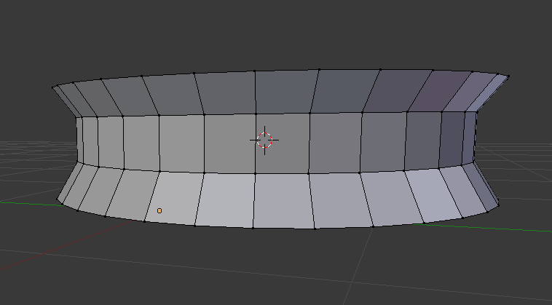Now create two loops on the side of the cylinder and space them an even distance apart. Then select the middles faces all the way around the cylinder and scale it inwards by **0.9.** To select all the faces around the circumference use **ALT + CLICK.**

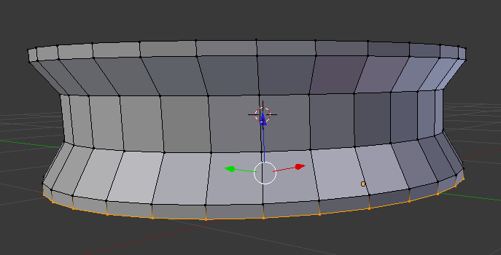

Now extrude the top and bottom then translate with **G** by **0.05** units. Do for both sides

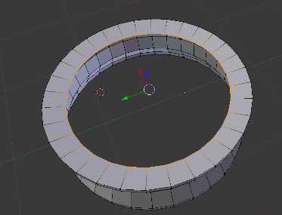

Next delete the side faces and select all vertices on the rim. Then, extrude and scale inwards by 0.8 units

Then translate downwards by 0.05 and do the same for the other side.

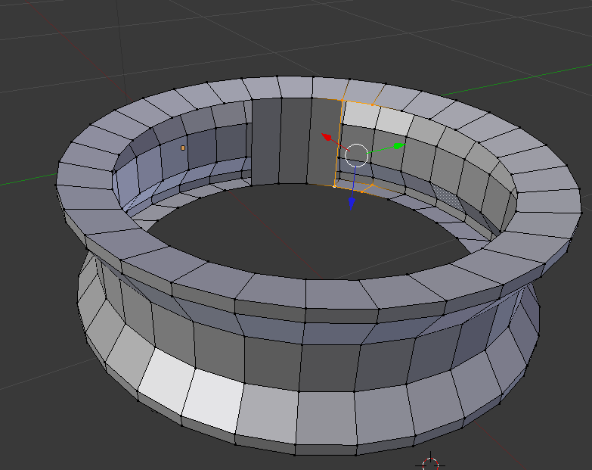

Now create faces for the inside of the wheel by selecting 4 points then clicking **F**

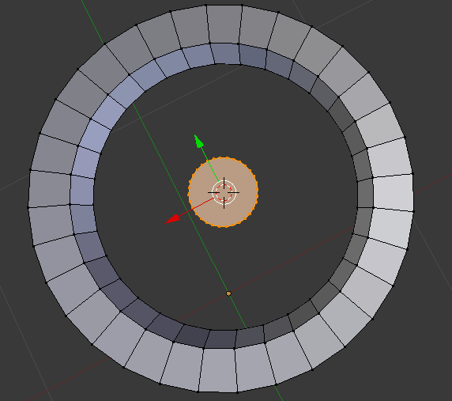Now select the whole object and **SHIFT + S** to bring cursor to selected. Then create a new cylinder and scale it down by **0.2** then scale it in the **Z** axis by **0.6**

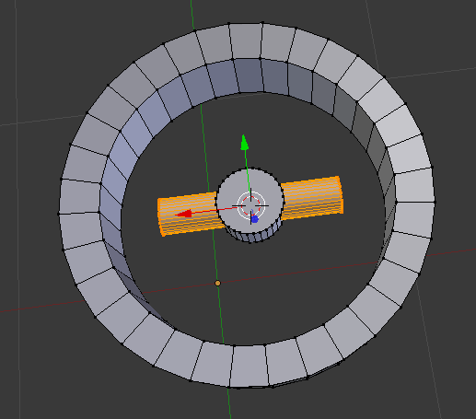

Now create another cylinder and rotate it in the **Y** axis by **90** degrees

Then scale down by **0.2** in **X** and **Y**

Then scale down the whole thing by **0.5**

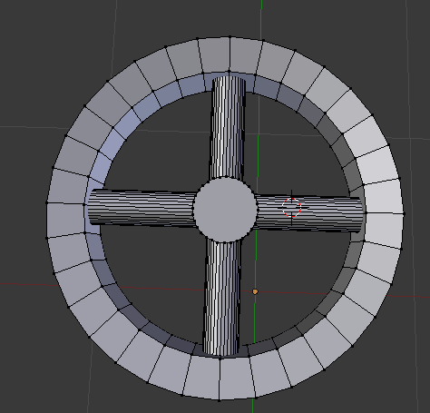

Scale it once more in the **X** axis by **0.8** and translate it in the **X** axis so it connects the inner cylinder to the outer one. This pole will act as a spoke.

Duplicate the cylinder and place it in the opposite direction. Do the same for the rest of the spokes

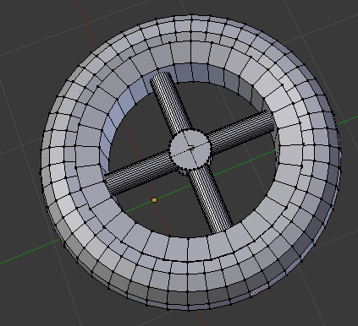

Now move cursor to selected and add a torus shape

Switch to side view and ensure it is properly aligned

Next scale the torus shape so it fits correctly. I scaled mine to **1.1**

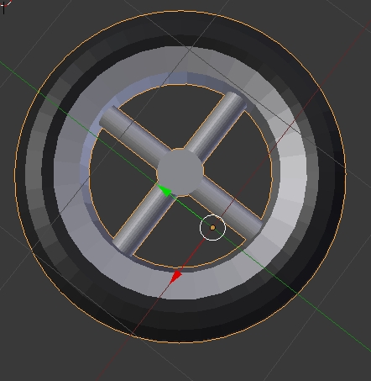Now create two loops on the outer side of the wheel an equal distance from the middle line

Use **ALT + CLICK** to select the whole circumference. Then select the faces and extrude and scale inwards by about **0.98**. this is to create the wheel threads.

Now add colour to the objects. Add a dark grey colour for the wheel and a silver colour for the spokes.

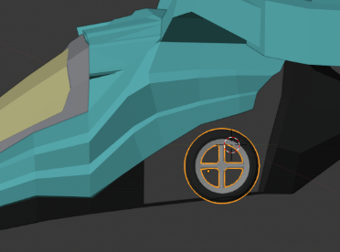Now let’s go back to the plane blender file and append the wheel we just created.

Rotate the wheel so it is properly aligned. Scale it down to fit in the vehicle underside. I scaled down by **0.3**

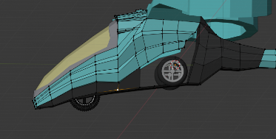Add a mirror modifier and to the wheel with the main body as the mirror. And duplicate a wheel for the front

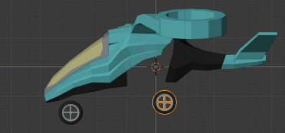Now lower the wheels, this is how the plane will look when it is landed

We will next add the pistons that will retract the wheels when in flight.

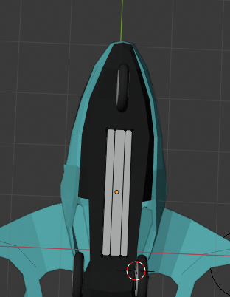

Create a cube and scale it down to **0.2** for **Z** and **Y**. then add two loops along the long side

Align your piston with your wheel

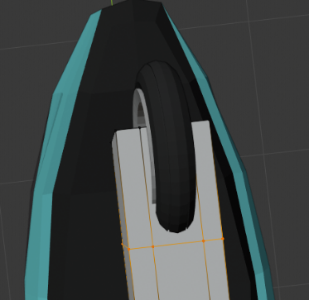

Add a loop cut going across the wheel fork. Now delete the faces that are obstructing the wheel

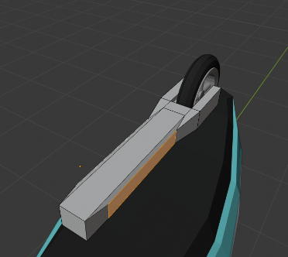

Next select the sides of the fork and scale them inwards to give the piston a wrench like shape now select the edges near the wheel and use **CTRL + B** to bevel them.

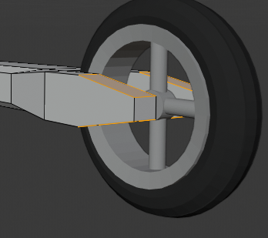

Use the bevel effect on the tips of the fork.

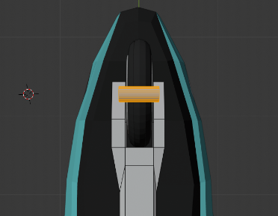

Now create a cylinder and rotate in **Y** by **90** then scale down to **0.1**

Expand in **X** direction by **1.3** and scale down in **Z** and **Y** by **0.5**

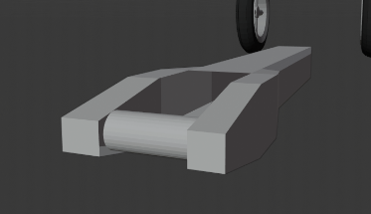

Now move the cylinder in place of the axle

Next up we need to fill these faces, disable the front wheel to see these easier

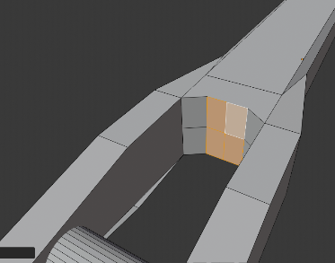

Translate these faces outwards to create more space for the wheel

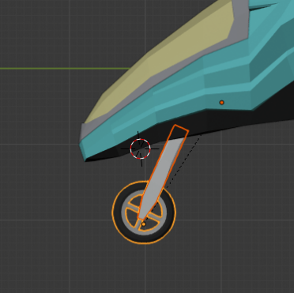

Now position the piston and wheel to fit to the body of the plane

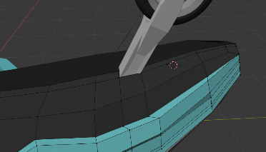

Add some loops to the underside, make sure to fit them close to the join section of the piston

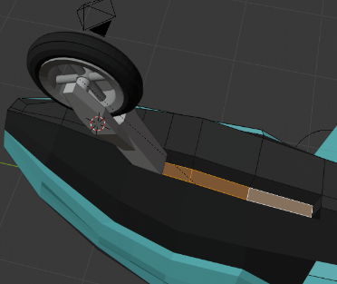Extrude and translate the faces as shown in the image.

Now click back to the piston and wheel and create a cylinder and scale it down so it fits into the gap. It will be the mechanism that moves our fork

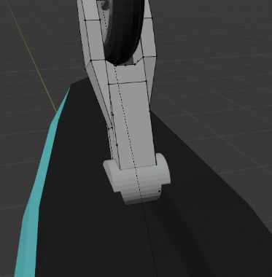

Add empty arrows to the center of the cylinder and make it a child of the cylinder

Next move cursor to the empty location and set the origin of the wheel and piston to the empty location. Now add a **limit rotation constraint** to the fork. And set the **X** rotation min to **0** and max to **180**. Ensure that local transform is used. Next add a **limit distance constraint**. This will limit the piston from moving anywhere and make animation easier.

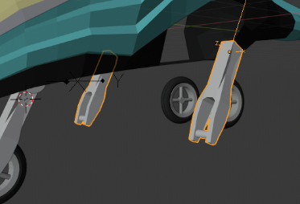

Next up switch to object mode and duplicate the fork you made earlier; you will need to remove the constraints from the new piston. Name it rear piston and add a mirror modifier to it. Then set the mirror object to the main body of the plane

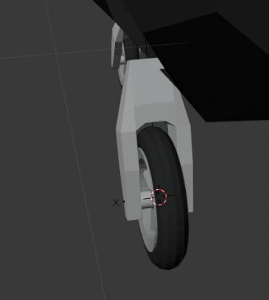

delete the faces of the shaft of the fork and align the fork to the wheel

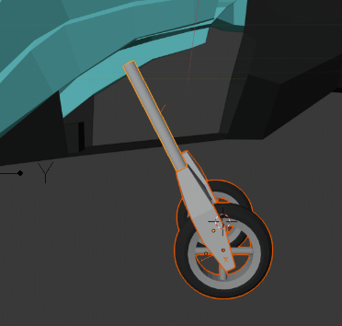

Create a cylinder with **0.05** radius and **1** depth this will be the shaft of the piston system we are creating

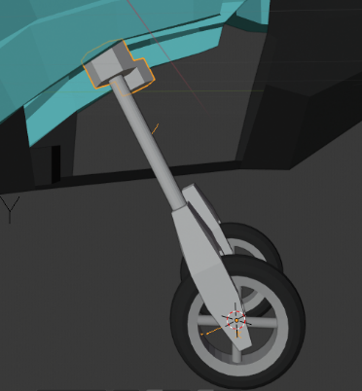

Add another cylinder and give it a **0.2** radius and a depth of **0.2**. Position it at the end of the piston

And an empty at the new cylinder and add a **track to** constraint to the wheel and connecting piston. Set the up axis to be **Y** and the facing to be **-Y**

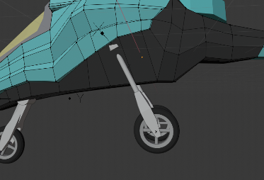Next up we’re going to fill up the empty space with new faces

Switch to edit mode on the main body extrude the edges the fill the empty space then merge the vertices with the body panel and the bottom of the plane

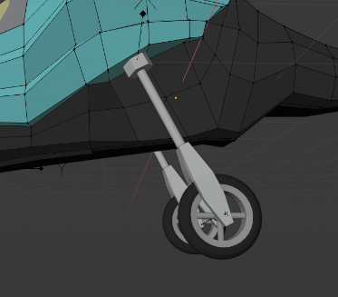Now we are going to create a loop along the body and use the new vertices to push the body of the plane inwards to make space for the pistons. Make sure to push only on the **X** axis.

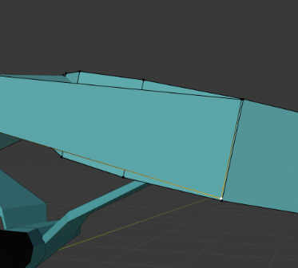Next we are going to connect the wings properly and round them out

Adjust the wings to make sure they are the same width as the gyro (this is the circle)

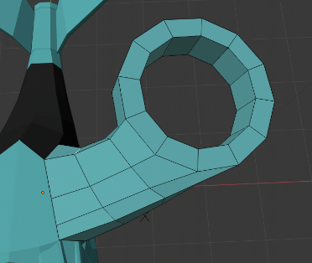

Add two loop cuts going across the wings on top.

Now merge the newly made vertices of the wing to the vertices of the gryo

Additionally, I used edge slide to align some of my edges as they were misaligned causing an odd shape

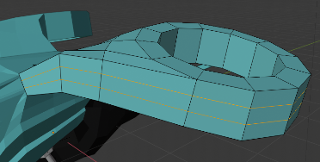

Next add two edge loops around the whole wing

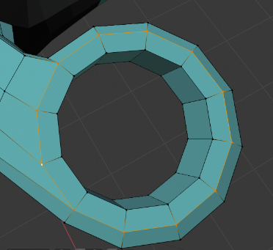

Select all the faces and scale it out along the normal to create a more rounded look

Select the top circle vertices of the gyro and scale them in. Do the same for the bottom

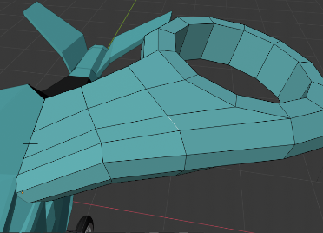You can see my lines going across are not straight so let’s straighten them out by using edge select and rotating them or using edge slide to align them. Ensure the shape of the wing is kept intact.

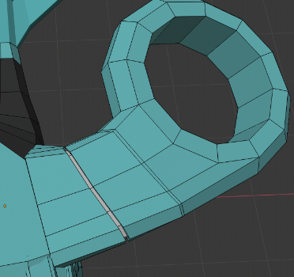Add two edge loops

Then select the inside faces and extrude. Then scale them in a small amount

Next change the colour to dark grey for the wing joining part. Do this twice as shown in the image.

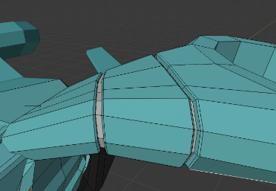

Afterwards select the edge and bevel it using ctrl B

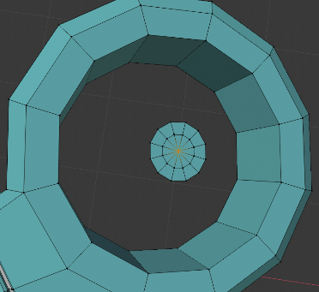

Next up we are going to create the fan that will be inside the gyro.

Firstly, we will create a hub cap in the middle. To do this select a circle of vertices of the gyro and duplicate then scale it down so it will be in the centre of the gyro

Extrude and scale again then merge at centre

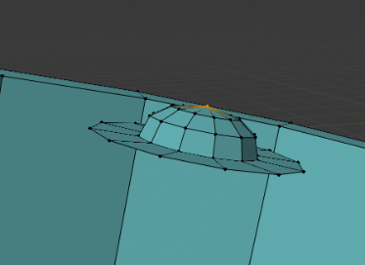

Now select the middle faces and switch to front view. Extrude upwards along the normal and scale inwards. Do this multiple times and merge at centre to finish the dome shape

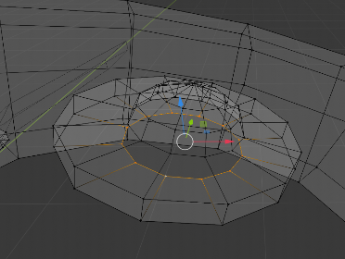

Now select the outer ring of vertices and extrude then pull down along the normal, to make this easier use the transform tools by present **T** and clicking move or transform. Then use the arrows and pull it down. Make sure **transform orientation** is set to **normal** for this

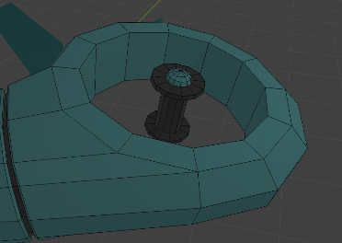You need to extrude then translate downwards along the normal then extrude again and scale inwards. Next extrude again and translate downwards until the bottom of the gyro. then repeat the steps before to create the hubcap on the bottom side. Also change the couloirs to match the image.

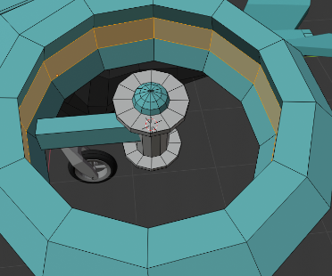 Next up is to create the blades of the propeller. Set the selector to the middle of the hubcap column and create a new cube

Scale it down so it fits within the hubcap column. Then scale it out length wise. Additionally, add two loop cuts along the inside and scale it outwards to make more space for the propeller blade

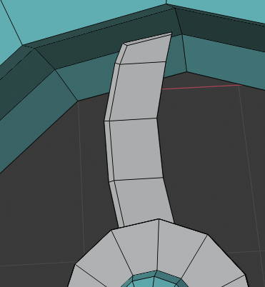

Flatten the blade then add 4 loop cuts on the side. Use the loop cuts to shape the blade into a curve. Once happy with the shape change the colour to a grey or silver colour

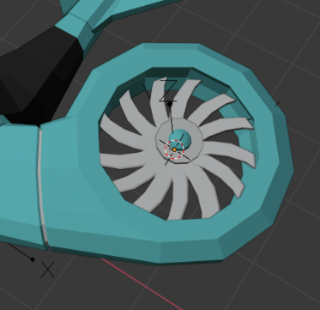Next up is to duplicate this, however, instead of using **SHIFT + D** we are going to use an array modifier so that in case we need to make any changes we only need to change one blade and the changes will propagate to the rest of the blades. Firstly, Create an empty at the center of the column. Now add an array modifier to the blade. Tick the object offset box and use the new empty you created as the object offset. Set the count to **15**. Ensure relative is ticked and all the values are set to **0**.

Once done, rotate the empty around the **Z** axis and you should see the blades fan out.

Also make sure that the mirror modifier is below the array modifier

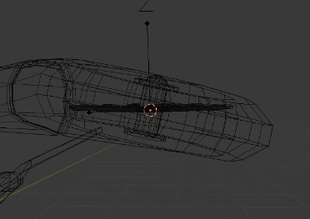Next up is to align the blades to the wing, because they are currently like this. Select both the empty and the blades and rotate them together about the **Y** axis.

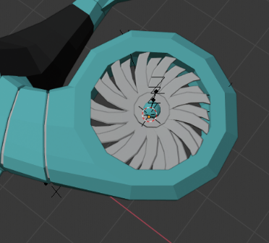

Next we are going to duplicate the blades and lower it by the **Z** normal. Then rotate so that both sets of blades can be seen.

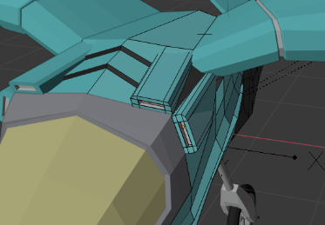

Next up some finishing touches, Change the color of the inside faces to white as these will be our lamps. Add some point lamps in the cut out area.

Make these sections dark grey to add some contrast.

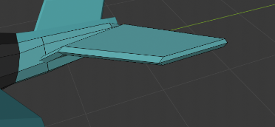

For the tail wings add a loop cut along the side and scale it out to give that aerodynamic effect